**Project report & documentation**

**Long term virtual internship on salesforce developer**

**Tittle of the project :** Recruiting assistance for the HR managers

**Industry mentor(s) name :** Mohammad saquib nadeem, shivam upadhye

**Faculty mentor(s) name :**  K.Anjaneyulu

**Team id :** LTVIP2023TMID08751

**Team size :**5

**Team leader :** Sowmya latha baglioni

**Team members :** T Sundupalli Sowmya

Nakkarasupalli Ganesh Kumar Reddy

Govardhan reddicherla

Gaddam poornachandra kumar

**1.introduction:**

**1.1. Overview:**

Recruiting assistance for HR managers involves providing support and aid throughout the entire recruitment process. It is designed to ease the burden on HR managers by delegating certain tasks to streamline and optimize the hiring process. Here's an overview of how recruiting assistance benefits HR managers:

1. **Job Description Development:** Assisting in creating comprehensive and attractive job descriptions that accurately represent the role and its requirements.
2. **Candidate Sourcing:** Utilizing various channels to source potential candidates, including job boards, social media, networking platforms, and professional associations.
3. **Applicant Screening:** Conducting initial screenings and shortlisting candidates who meet the necessary qualifications, skills, and experience.
4. **Interview Coordination:** Scheduling and coordinating interviews with candidates and relevant stakeholders, ensuring a smooth process.
5. **Candidate Assessment:** Assisting with candidate assessments, such as skills tests, behavioural interviews, and competency evaluations.
6. Reference Checks: Conducting reference checks to validate the candidate's past work experience and performance.
7. **Offer Negotiation:** Supporting HR managers in crafting competitive job offers and handling negotiations with candidates.
8. **Onboarding Support:** Providing a structured onboarding process for the selected candidate to ensure a seamless integration into the organization.

Recruiting assistance allows HR managers to focus on more strategic tasks, such as talent development, employee engagement, and workforce planning. It also enables a faster and more efficient recruitment process, leading to reduced time-to-fill vacancies and ensuring the organization attracts and retains top talent. By leveraging external support or specialized tools, HR managers can optimize their recruitment efforts and build a strong and capable workforce for the organization's success**.**

**1.2. Purpose:**

The use of the recruiting assistance project for HR managers can lead to several valuable outcomes for an organization:

**1. Improved Recruitment Efficiency:** By delegating various tasks to the recruiting assistance team, HR managers can streamline the recruitment process, leading to quicker candidate sourcing, screening, and selection.

**2. Access to Specialized Expertise:** The recruiting assistance team may have specialized knowledge in candidate sourcing, screening techniques, and recruitment best practices, providing HR managers with access to valuable expertise.

**3. Higher Quality Hires:** With a more efficient and focused recruitment process, the organization is likely to attract better-suited candidates, leading to higher-quality hires who fit the job requirements and company culture.

**4. Reduced Workload for HR Managers:** Delegating tasks to the recruiting assistance team allows HR managers to concentrate on strategic HR initiatives, employee development, and other high-value responsibilities.

**5. Scalability and Flexibility:** The project can adapt to the organization's changing needs, expanding or reducing assistance as recruitment demands fluctuate.

**6. Consistency and Standardization:** The recruiting assistance team can help ensure a consistent and standardized recruitment process across all departments and positions, promoting fairness and reducing bias.

**7. Enhanced Candidate Experience:** A more organized and efficient recruitment process can result in a positive candidate experience, strengthening the organization's employer brand and reputation.

**8. Cost Savings:** By optimizing the recruitment process, the organization can reduce time-to-fill vacancies, minimize hiring costs, and avoid potential productivity losses due to prolonged vacancies.

**9. Compliance and Legal Adherence:** Recruiting assistance teams can help ensure the organization follows hiring laws and regulations, reducing the risk of legal issues related to recruitment practices.

Overall, the recruiting assistance project empowers HR managers to make better-informed hiring decisions while improving the overall efficiency and effectiveness of the recruitment process. It contributes to building a strong and talented workforce, which is essential for an organization's growth and success in a competitive business landscape.

**2.literature survey:**

**2.1. Existing problem:**

Existing approaches and methods to solve the problem of recruiting assistance for HR managers include:

**1. HR Outsourcing:** Organizations can partner with external HR service providers that offer specialized recruitment assistance, taking care of sourcing, screening, and shortlisting candidates according to the organization's requirements.

**2. Recruitment Agencies:** Collaborating with recruitment agencies can provide access to a pool of pre-screened candidates, saving time and effort in the hiring process.

**3. Applicant Tracking System (ATS):** Implementing an ATS helps streamline candidate management, ensuring a smooth and organized recruitment process.

**4. Employee Referral Programs:** Encouraging existing employees to refer potential candidates can be a cost-effective and efficient way to source candidates who may align with the company's culture.

**5. social media and Job Portals:** Utilizing social media platforms and job portals can help reach a wider audience and attract potential candidates from diverse backgrounds.

**6. Behavioural and Competency-Based Interviews:** Conducting structured interviews focused on behavioural and competency-based questions provides insights into a candidate's skills and suitability for the role.

**7. Recruitment Marketing:** Implementing recruitment marketing strategies can enhance the organization's employer brand and attract top talent.

**8. Talent Pipelining:** Building and maintaining a talent pipeline enables HR managers to have a pool of potential candidates ready for future openings.

**9. Diversity and Inclusion Initiatives:** Actively promoting diversity and inclusion in the recruitment process can lead to a more diverse and representative workforce.

**10. Recruitment Analytics:** Utilizing data and analytics to track recruitment metrics can help identify areas for improvement and optimize the hiring process.

**11. Campus recruitment:** Partnering with educational institutions for campus recruitment programs can help attract fresh talent and future leaders.

**12. Internal Mobility Programs:** Encouraging internal candidates to apply for open positions can promote career growth within the organization.

By employing these approaches, HR managers can efficiently and effectively manage the recruitment process, ensuring the organization attracts and hires the best-suited candidates for its workforce needs.

* 1. **Proposed solution:**

As an AI language model, I don't have personal preferences or opinions, but I can suggest a comprehensive method for the recruiting assistance for HR managers project:

**1. Needs Assessment**: Conduct a thorough analysis of the organization's recruitment needs, including the specific roles to be filled and the required skills and qualifications.

**2. Establish Clear Job Descriptions:** Work with HR managers to create clear and detailed job descriptions for each position to ensure a targeted and efficient recruitment process.

**3. Collaborate with HR Managers:** Partner closely with HR managers to understand their preferences and expectations, ensuring that the recruiting assistance aligns with their goals.

**4. Recruitment Strategy Development:** Develop a customized recruitment strategy tailored to the organization's industry, size, and talent requirements.

**5. Candidate Sourcing:** Use various channels like job boards, social media, and professional networks to source potential candidates.

**6. Candidate Screening**: Assist in screening resumes and applications to shortlist qualified candidates for further assessment.

**7. Interview Coordination**: Coordinate interview schedules, ensuring efficient communication with candidates and interviewers.

**8. Behavioural and Competency-Based Interviews:** Help design structured interviews that focus on behavioural and competency-based questions to assess candidates effectively.

**9. Reference Checks:** Conduct reference checks to verify candidate qualifications and past work experiences.

**10. Candidate Feedback:** Provide constructive feedback to candidates throughout the recruitment process to maintain a positive candidate experience.

**11. Offer Management:** Assist in crafting competitive job offers and managing negotiations with selected candidates.

**12. Onboarding Support:** Work with HR managers to design a comprehensive onboarding process for successful candidates.

**13. Recruitment Analytics:** Utilize recruitment data and analytics to evaluate the effectiveness of the recruitment process and make data-driven improvements.

**14. Compliance and Diversity:** Ensure adherence to legal and regulatory requirements and promote diversity and inclusion in the hiring process.

By implementing this method, HR managers can benefit from specialized assistance at every stage of the recruitment process, leading to improved efficiency, reduced time-to-fill positions, and better-quality hires. Additionally, this approach ensures a positive candidate experience, which enhances the organization's reputation as an employer of choice.

**3.THEORITICAL ANALYSIS:**

**3.1 Block diagram:**

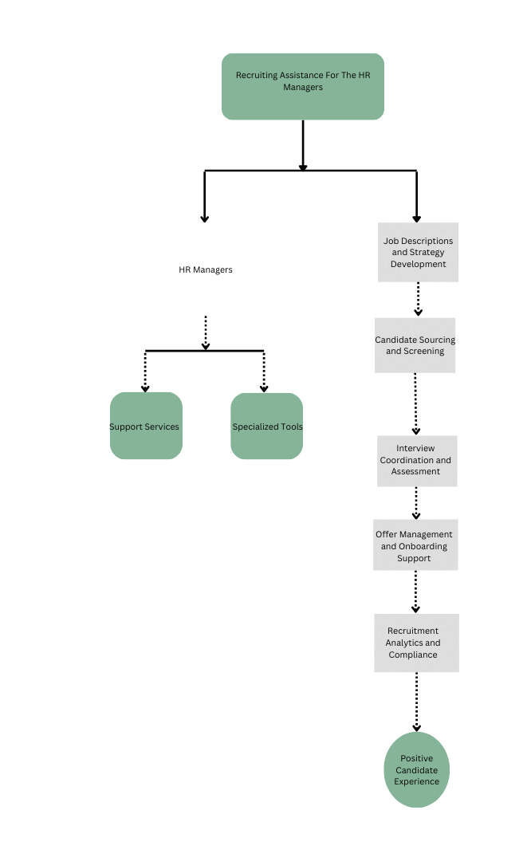

**3.2 Hardware / Software designing:**

The hardware and software requirements for the recruiting assistance project for HR managers may vary depending on the scale of the project and the specific tools or systems chosen for implementation. However, here are some general requirements:

**Hardware Requirements:**

**1. Computers/Laptops:** HR managers and recruiting assistance team members will need computers or laptops to access the necessary software and tools for recruitment tasks.

**2. Internet Connection:** A reliable and high-speed internet connection is essential for seamless communication, candidate sourcing, and accessing cloud-based software.

**3. Server/Cloud Storage:** If the organization uses an applicant tracking system (ATS) or other cloud-based recruitment tools, a server or cloud storage is required to store candidate data securely.

**4. Printers and Scanners:** Physical documentation may still be required, so printers and scanners can be useful for handling paperwork.

**Software Requirements:**

**1. Applicant Tracking System (ATS):** An ATS is essential for managing the candidate pipeline, tracking applications, and communicating with candidates throughout the recruitment process.

**2. Collaboration and Communication Tools:** Software like Microsoft Teams, Slack, or other collaboration platforms are helpful for coordinating tasks and maintaining smooth communication within the recruitment team.

**3. HR Software Suite:** Depending on the organization's HR management system, an HR software suite may be used to integrate recruitment data with other HR functions.

**4. Recruitment Analytics Tools:** Software for analyzing recruitment metrics and data to make data-driven decisions and improve the recruitment process.

**5. Microsoft Office Suite:** Word processing, spreadsheet, and presentation software are commonly used for creating job descriptions, candidate evaluation sheets, and recruitment reports.

**6. Video Conferencing Tools:** Virtual interviews and communication with candidates may require video conferencing software like Zoom, Skype, or Google Meet.

**7. Social Media Management Tools:** To efficiently manage recruitment campaigns on social media platforms.

**Security Requirements:**

1. **Data Security Measures:** Ensure that all software and systems used for candidate data management have robust security features to protect candidate information.

**2. Access Controls:** Implement access controls to limit data access to authorized personnel only.

**Integration Requirements:**

**1. Integration with HR Systems:** The applicant tracking system and other recruitment tools may need to integrate with the organization's HR systems for seamless data sharing and reporting.

**2. Compatibility**: Ensure that the chosen software and tools are compatible with the organization's existing hardware and operating systems.

It's important to note that the specific requirements may vary depending on the organization's existing infrastructure, preferences, and budget constraints. Hence, before implementing the project, a thorough assessment of the organization's needs and available resources is necessary to select the most suitable hardware and software solutions.

**4. RESULT:**

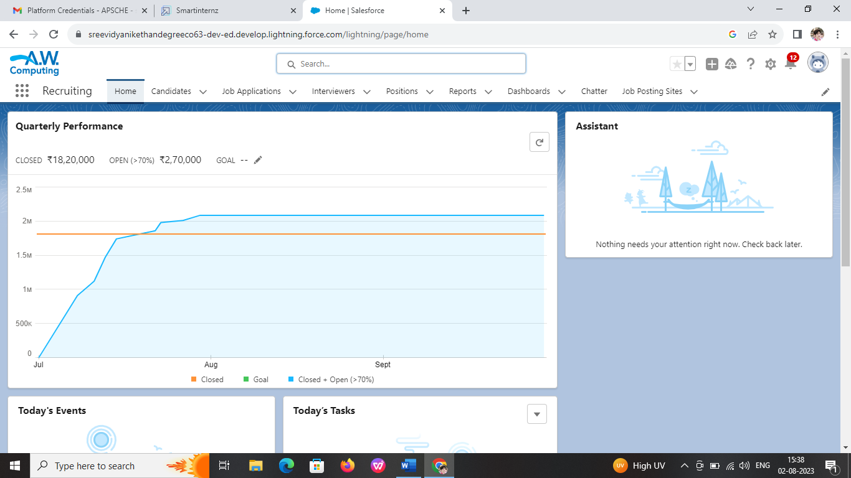

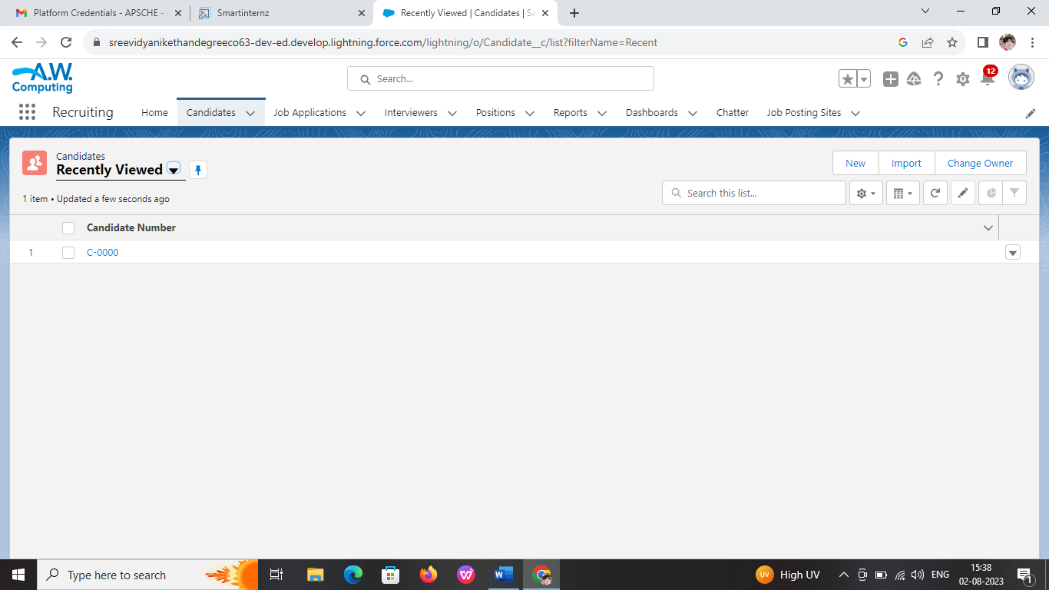

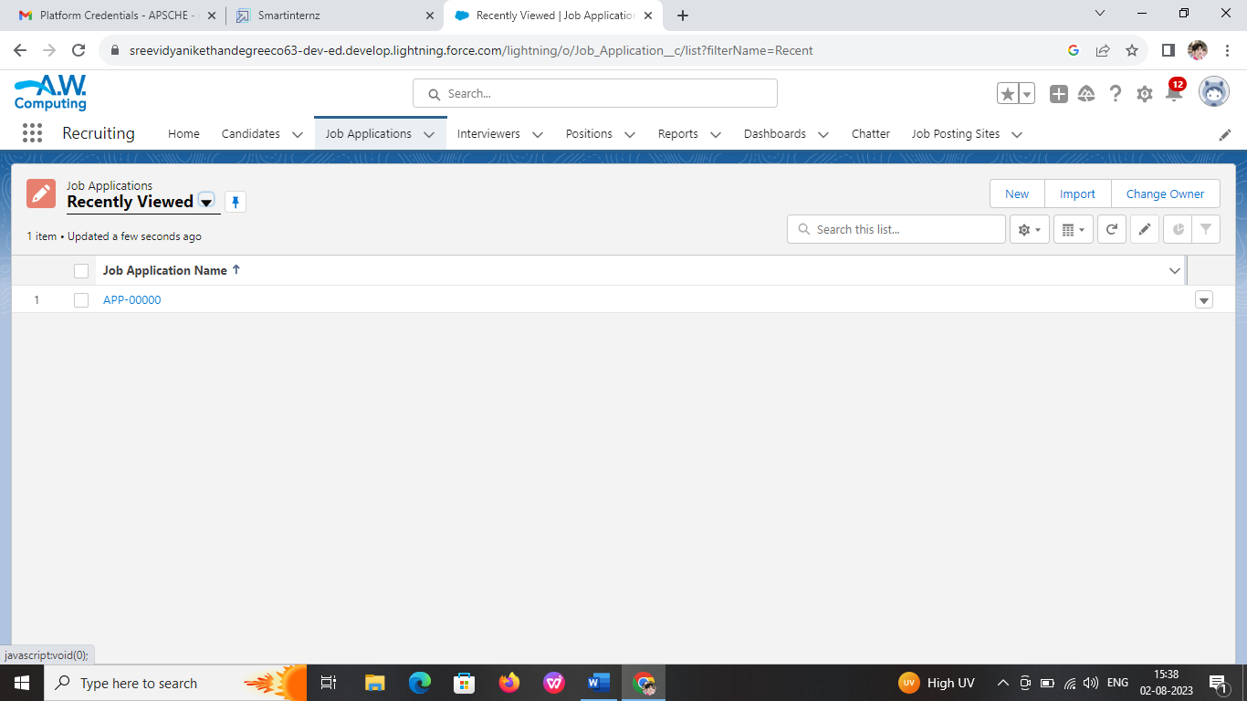

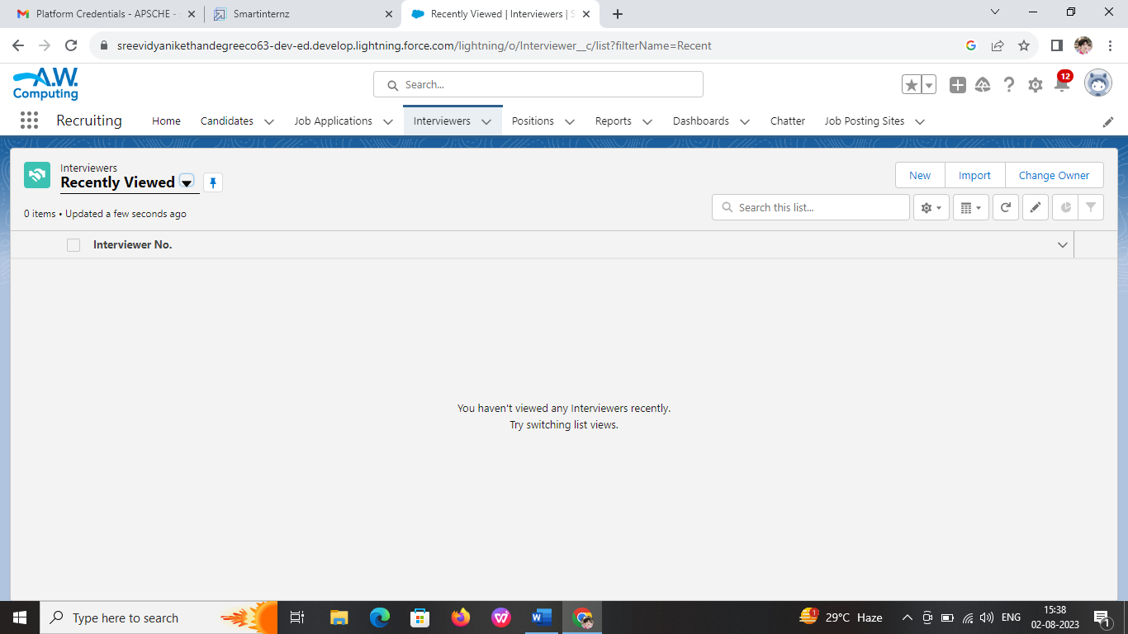

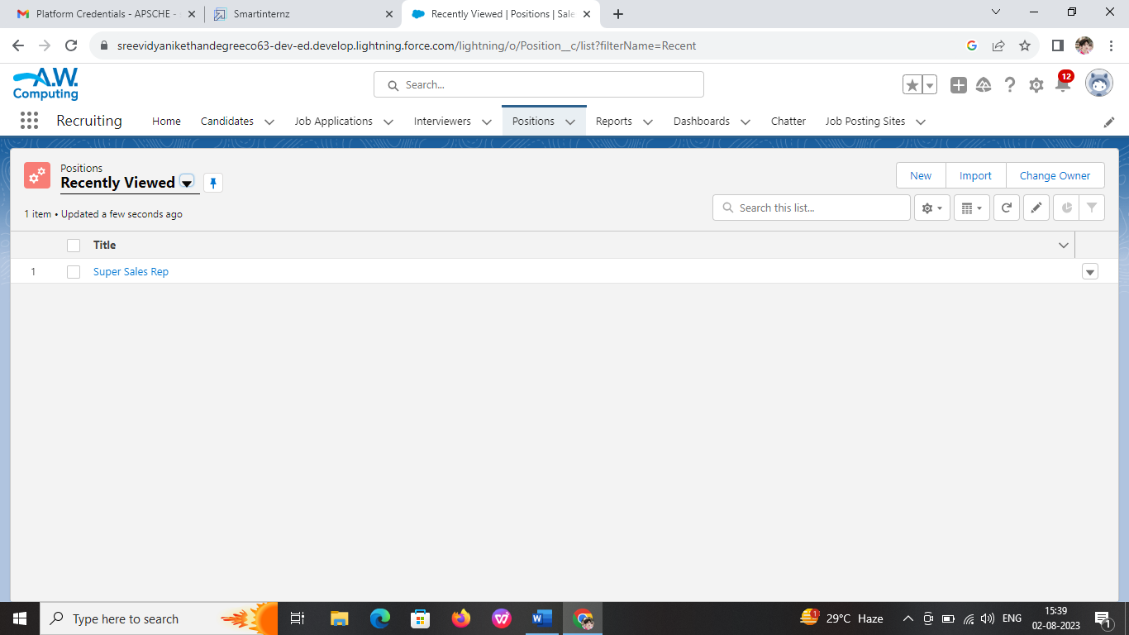

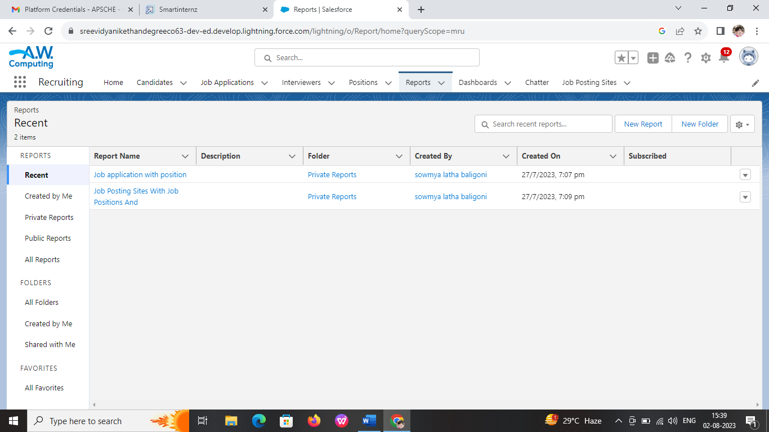

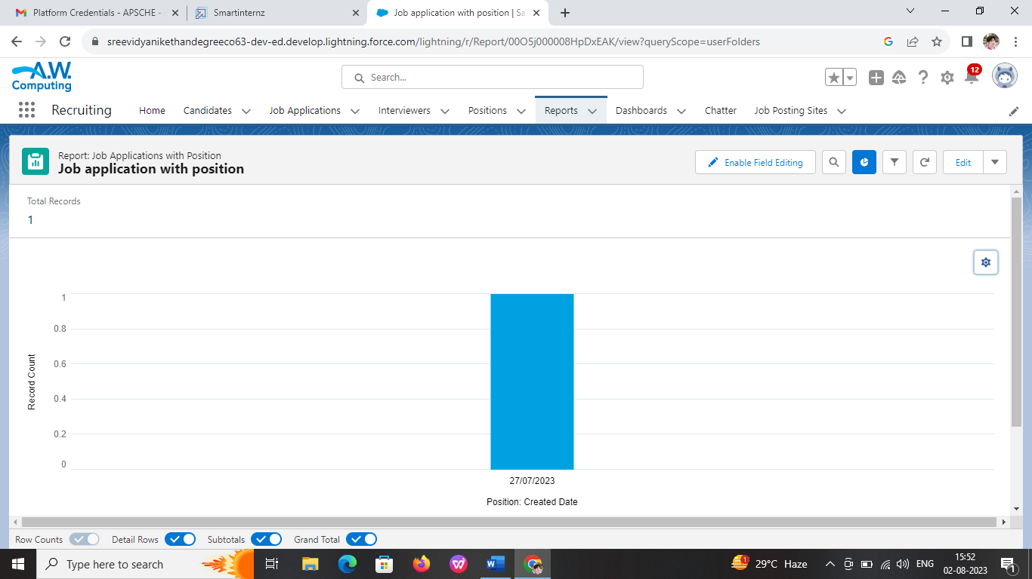

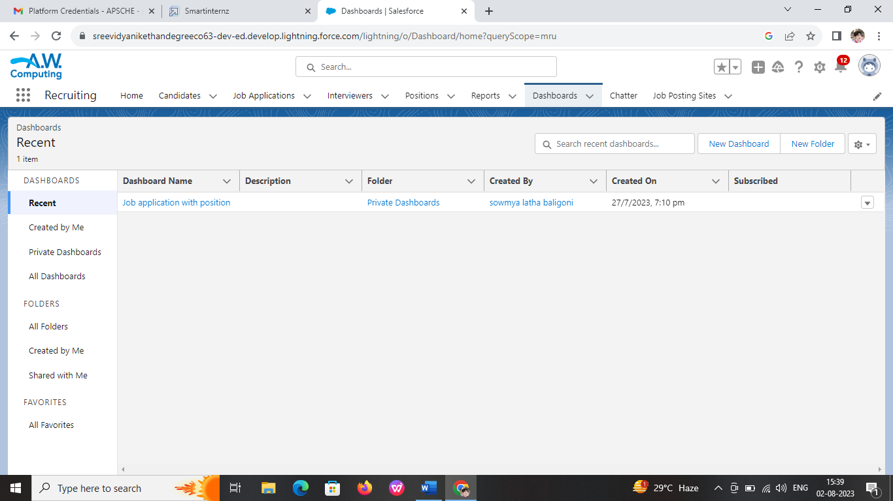

**5. ADVANTAGES & DISADVANTAGES:**

**Advantages of the Proposed Solution:**

**1. Improved Efficiency**: The recruiting assistance project streamlines the recruitment process, leading to faster candidate sourcing, screening, and selection, reducing time-to-fill vacancies.

**2. Quality Hires:** With specialized assistance in candidate screening and assessments, the project can lead to better-quality hires who align with the organization's needs and culture.

**3. Focus on Strategic HR Initiatives:** By delegating recruitment tasks, HR managers can devote more time to strategic HR planning, talent development, and employee engagement.

**4. Positive Candidate Experience:** A well-organized and efficient recruitment process ensures candidates have a positive experience, enhancing the organization's employer brand.

**5. Scalability:** The project can adapt to changing recruitment demands, easily scaling up or down as needed.

**6. Data-Driven Decisions:** Utilizing recruitment analytics provides valuable insights for optimizing the hiring process and making data-driven decisions.

**7. Cost Savings:** A streamlined recruitment process may result in cost savings related to reduced time and resources spent on recruitment.

**8. Access to Expertise:** The project provides HR managers with access to specialized expertise from the recruiting assistance team.

**Disadvantages of the Proposed Solution:**

**1. Initial Setup Time:** Implementing the recruiting assistance project may require time and resources to set up new systems and train the recruiting assistance team.

**2. Compatibility Issues:** Integrating new software and tools may encounter compatibility challenges with existing HR systems.

**3. Dependence on External Services:** If the project relies heavily on external service providers, any disruption in their services may impact the recruitment process.

**4. Costs:** Depending on the scale and scope of the project, recruiting assistance services or specialized tools may incur additional costs.

**5. Data Security Concerns:** Sharing candidate data with external parties requires stringent data security measures to protect candidate information.

**6. Training and Onboarding:** HR managers and the recruiting assistance team may require training to effectively collaborate and work together.

**7. Over-Reliance on Automation:** Over-reliance on automation may lead to overlooking unique candidate qualities that cannot be measured solely through data-driven assessments.

**8. Cultural Fit Assessment:** Relying solely on external recruiting assistance may pose challenges in evaluating candidates' cultural fit with the organization.

It's essential to carefully consider these advantages and disadvantages while planning and implementing the recruiting assistance project to ensure that the benefits outweigh the challenges and effectively meet the organization's recruitment needs.

**6. APPLICATIONS:**

The proposed solution of recruiting assistance for HR managers can be applied in various areas of recruitment and talent acquisition within an organization. Some of the key areas where this solution can be effectively applied include:

**1. Full-Time Hiring:** For regular full-time positions, the recruiting assistance project can help HR managers streamline the process, attract top talent, and make high-quality hires.

**2. Temporary or Contract Staffing:** The project can assist in sourcing and selecting temporary or contract staff for short-term projects or seasonal demands.

**3. Campus Recruitment:** Recruiting assistance can be valuable in managing campus recruitment efforts to attract fresh talent from universities and colleges.

**4. Executive Recruitment:** For critical executive-level positions, the project can provide specialized assistance in sourcing and assessing candidates.

**5. Remote Recruitment:** In the era of remote work, recruiting assistance can facilitate the process of hiring candidates from different geographical locations.

**6. High-Volume Hiring:** For organizations with frequent hiring needs, such as in retail or customer service industries, the project can efficiently manage high-volume recruitment efforts.

**7. Diversity and Inclusion Recruitment:** The solution can be applied to promote diversity and inclusion in the recruitment process, ensuring a more diverse workforce.

**8. Skill-Specific Hiring:** For specialized roles that require niche skills, recruiting assistance can help identify candidates with the required expertise.

**9. Succession Planning**: The project can be applied in identifying potential internal candidates for succession planning purposes.

**10. International Recruitment:** When hiring candidates from different countries, the project can provide support in navigating international recruitment processes.

**11. Referral Programs:** The solution can aid in managing employee referral programs, encouraging employees to refer potential candidates.

**12. Industry-Specific Recruitment:** In industries with unique recruitment challenges, such as healthcare or technology, the project can offer tailored assistance.

Overall, the recruiting assistance project is versatile and applicable in various recruitment scenarios, enabling HR managers to efficiently and effectively fill different types of positions, attract the right talent, and build a strong and capable workforce for the organization's success.

**7. CONCLUSION:**

In conclusion, the proposed solution of recruiting assistance for HR managers aims to enhance the efficiency and effectiveness of the recruitment process within an organization. By providing ongoing support and specialized assistance, HR managers can streamline their recruitment efforts, attract high-quality candidates, and improve the overall candidate experience.

Throughout the project, several advantages were identified, including improved recruitment efficiency, better-quality hires, increased focus on strategic HR initiatives, and cost savings. The use of recruitment analytics and data-driven decision-making further optimizes the hiring process, ensuring better outcomes.

However, there are also potential challenges, such as initial setup time, data security concerns, and compatibility issues. These challenges need careful consideration and mitigation to ensure a successful implementation of the recruiting assistance project.

Overall, the recruiting assistance solution can be applied in various areas of recruitment, including full-time hiring, executive recruitment, diversity and inclusion efforts, campus recruitment, and high-volume hiring. It provides HR managers with the necessary tools and support to attract top talent, build a strong workforce, and foster a positive employer brand.

In conclusion, the recruiting assistance project empowers HR managers to make informed hiring decisions, optimize their recruitment processes, and ultimately contribute to the organization's success by building a talented and capable workforce. The ongoing assistance and support offered through this solution position HR managers to focus on strategic initiatives while effectively meeting the organization's talent acquisition needs.

1. **FUTURE SCOPE:**

In the future, several enhancements can be made to further improve the recruiting assistance solution for HR managers:

**1. Artificial Intelligence and Automation:** Integrate AI-driven tools and automation in candidate sourcing, screening, and assessment to accelerate the recruitment process and identify the best-fit candidates more efficiently.

**2. Predictive Analytics:** Implement predictive analytics to forecast future recruitment needs, enabling proactive talent acquisition and succession planning.

**3. Virtual Reality (VR) and Augmented Reality (AR) Assessments:** Utilize VR/AR technology for immersive candidate assessments, especially for roles that require specific technical or hands-on skills.

**4. Mobile Recruitment:** Develop mobile-friendly recruitment platforms to cater to candidates who prefer to engage with the hiring process through their mobile devices.

**5. Social Media Integration:** Enhance social media recruitment efforts by integrating with platforms like LinkedIn and Twitter to reach a broader and more targeted candidate pool.

**6. On-Demand Video Interviews:** Introduce on-demand video interviews to assess candidates' communication skills and fit with the organization's culture more effectively.

**7. Gamification:** Incorporate gamification elements in the recruitment process to engage candidates and assess their problem-solving and critical thinking abilities.

**8. Candidate Relationship Management (CRM) System:** Implement a CRM system to nurture candidate relationships and maintain a talent pipeline for future openings.

**9. Continuous Candidate Feedback:** Establish a feedback mechanism for candidates to provide input on their recruitment experience, enabling continuous improvement.

**10. AI-Powered Chatbots:** Integrate AI chatbots on the organization's career page or application portals to provide real-time assistance to candidates and answer frequently asked questions.

**11. Personalized Candidate Experience:** Tailor the recruitment process to individual candidates based on their preferences and interests to enhance the candidate experience.

**12. Remote Hiring Tools:** Develop remote hiring tools that support virtual interviews, online assessments, and virtual onboarding for geographically dispersed candidates.

**13. Skills Testing and Training:** Offer skills testing and training modules to candidates to assess their abilities and provide learning opportunities to upskill for specific roles.

By implementing these enhancements, the recruiting assistance solution can become even more efficient, engaging, and data-driven, leading to improved candidate selection, a more positive candidate experience, and better alignment with the organization's talent acquisition goals. Continuous innovation and adaptation to emerging technologies will ensure that the recruiting assistance project remains at the forefront of modern recruitment practices in the future.